FINAL PROJECT
DIGITAL WATER LEVEL DISPLAY

Group Members Information
NAME | REGISTRATION NO.
- Mirza Amjad Baig | 2025-CS-267
- Ameer Mauwia | 2025-CS-250
- Noraiz Khan | 2025-CS-282
- Zaman Abbas | 2025-CS-285
- Shahzaib Ahmed | 2025-CS-252

Instructor Name: Ma’am Aroosh Fatima.

TABLE OF CONTENTS
Abstract 3
Introduction 3
Objectives 3
Components List 3
Theory 4
Priority Encoder (74HC147) 4
Hex Inverter (74HC04) 5
BCD-to-7-Segment Decoder (CD4511) 5
Power Supply (LM7805) 5
Circuit Design 5
Signal Flow 5
Encoder Truth Table 6
Proteus Simulation 6
Proteus Schematic Screenshot 7
Simulation Running 7
Simulation Results Table 8
Hardware Implementation 8
Breadboard Circuit (Full View) 9
IC Close-up (74HC147, 74HC04, CD4511) 9
Display Output (Hardware Test) 10
Working Principle 10
Advantages & Limitations 10
Conclusion 11

Abstract
This project presents a Digital Water Level Display built using three combinational logic ICs the 74HC147 Priority Encoder, the 74HC04 Hex Inverter, and the CD4511 BCD-to-7-Segment Decoder assembled on a solderless breadboard. Nine conductive sensor probes placed at different heights inside a water tank detect the water level. The encoder converts the highest active sensor into a 4-bit BCD code; the inverter corrects active-low logic; and the decoder drives a common-cathode 7-segment display to show a digit from 0 (empty) to 9 (full). Power is supplied by a 9 V battery regulated to 5 V by an LM7805. The circuit was designed, simulated in Proteus 8 Professional, and implemented on hardware.

Introduction
Water is one of the most critical resources in both domestic and industrial environments. Knowing the exact level of water inside a storage tank is essential to avoid overflow, dry-running of pumps, and unnecessary wastage. Traditionally, mechanical float gauges have been used for this purpose; however, they are prone to wear, corrosion, and inaccuracy.
The Digital Water Level Display system replaces mechanical gauges with an all-electronic, digital circuit. It provides an accurate, real-time, single-digit readout on a 7-segment LED display, indicating the water level on a scale of 0 (empty) to 9 (full). This project is particularly significant from the perspective of Digital Logic Design because it integrates three key combinational building blocks.
The project was designed and simulated using Proteus Professional schematic capture and simulation environment. The simulation confirms correct operation for all water levels from 0 to 9.

Objectives
- Understand and apply the 74HC147 priority encoder in a practical circuit.
- Understand the need for logic-level inversion between encoder and decoder.
- Implement the CD4511 BCD decoder to drive a 7-segment display.
- Assemble the complete circuit on a solderless breadboard.
- Simulate and verify correct operation for all water levels (0–9) in Proteus.

Components List
# | Component | Specification | Quantity | Purpose
1 | Solderless Breadboard | Standard 830-tie | 1 | Circuit assembly platform
2 | Voltage Regulator | LM7805 (5 V) | 1 | Regulates 9 V battery to 5 V DC
3 | Priority Encoder IC | 74HC147 (Decimal to BCD) | 1 | Encodes water level to 4-bit BCD
4 | Hex Inverter IC | 74HC04 | 1 | Inverts active-LOW BCD to active-HIGH
5 | BCD-to-7-Segment Decoder IC | CD4511 | 1 | Decodes BCD and drives 7-segment display
6 | 7-Segment Display | Common Cathode | 1 | Displays water level digit (0–9)
7 | Resistor | 560 kΩ | 9 | Pull-up resistors for encoder inputs
8 | Resistor | 100 Ω | 1 | Current limiting for 7-segment segments
9 | Capacitor | 104 pF (0.1 µF) Ceramic | 2 | Decoupling caps for LM7805 regulator
10 | Male-to-Male Jumper Wires | Standard | × | IC-to-IC connections on breadboard
11 | Male Header Pins | Standard | × | Sensor probe connection points
12 | Hard Jumper Wire | Solid-core | × | Power and ground rails on breadboard
13 | Battery Clip | 9 V PP3/6F22 type | 1 | Connects battery to circuit
14 | 9 V Battery | PP3 / 6F22 | 1 | Primary power source

Theory

Priority Encoder (74HC147)
The 74HC147 is a 10-to-4 BCD priority encoder. It has 9 active-LOW data inputs (I1- I9) and produces a 4-bit active-LOW BCD output (D, C, B, A). If several inputs are active at the same time, the highest-numbered input wins (priority). When no input is active, the output is 1111 which inverts to 0000 (decimal 0). The pull-up resistors (560 kΩ) keep all unused inputs HIGH.

Hex Inverter (74HC04)
The 74HC04 contains six independent NOT gates. Since the 74HC147 outputs active-LOW BCD and the CD4511 requires active-HIGH BCD, each of the four BCD bits is passed through an inverter gate to produce the correct logic levels. For example, encoder output 1010 (active-LOW for level 5) becomes 0101 after inversion the correct BCD for decimal 5.

BCD-to-7-Segment Decoder (CD4511)
The CD4511 accepts a 4-bit BCD input and drives seven segment outputs (a–g), all active-HIGH, for a common-cathode display. Three control pins must be configured for normal operation:
- LT (Lamp Test, Pin 3) - tie to VCC (HIGH)
- BL (Blanking, Pin 4) - tie to VCC (HIGH)
- LE (Latch Enable, Pin 5) - tie to GND (LOW)

Power Supply (LM7805)
The LM7805 three-terminal regulator converts the 9 V battery to a stable +5 V DC rail. Two 104 pF (0.1 µF) ceramic capacitors one at the input pin, one at the output pin suppress noise and ensure stability. All IC VCC pins and the display are powered from this +5 V rail.

Circuit Design

Signal Flow
Stage | Component | Function
Sensing | 9 Probes + 560 kΩ Pull-ups | Input High normally; water contact pulls LOW
Encoding | 74HC147 | Active-Low BCD output of highest active sensor
Inversion | 74HC04 | Converts active-Low to active-High BCD
Decoding & Display | CD4511+7-Seg Display | Drives segments to show level digit 0–9

Encoder Truth Table
Level | Active Input | Encoder Out (Active-LOW) | After Inversion (BCD) | Display
0 (Empty) | None | 1111 | 0000 | 0
1 | I1 | 1110 | 0001 | 1
2 | I2 | 1101 | 0010 | 2
3 | I3 | 1100 | 0011 | 3
4 | I4 | 1011 | 0100 | 4
5 | I5 | 1010 | 0101 | 5
6 | I6 | 1001 | 0110 | 6
7 | I7 | 1000 | 0111 | 7
8 | I8 | 0111 | 1000 | 8
9 | I9 | 0110 | 1001 | 9

Proteus Simulation
The schematic was drawn in Proteus 8 ISIS using the 74HC147, 74HC04, 4511, and 7SEG-COM-CATHO components. LOGICSTATE inputs simulated the sensor probes. The simulation was run for all ten water levels and all displayed correctly.

Proteus Schematic Screenshot
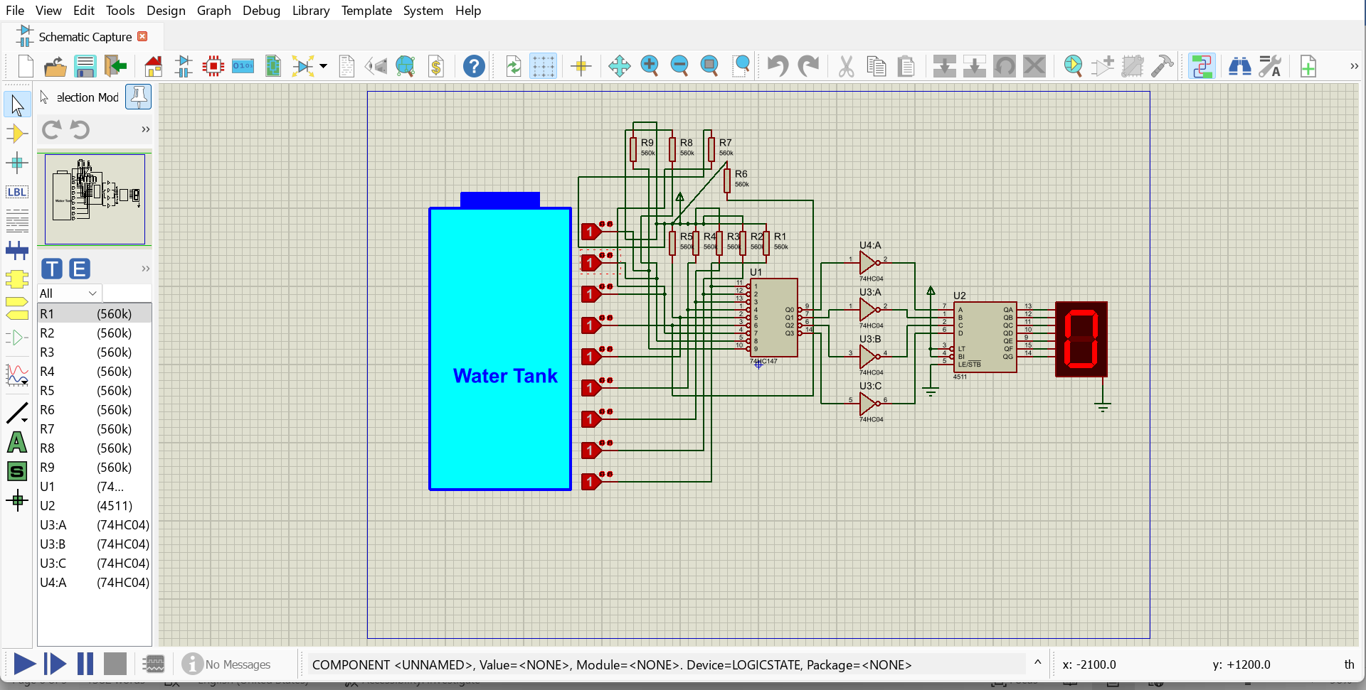

Figure 1 - Schematic of Digital Water Level Display

Simulation Running
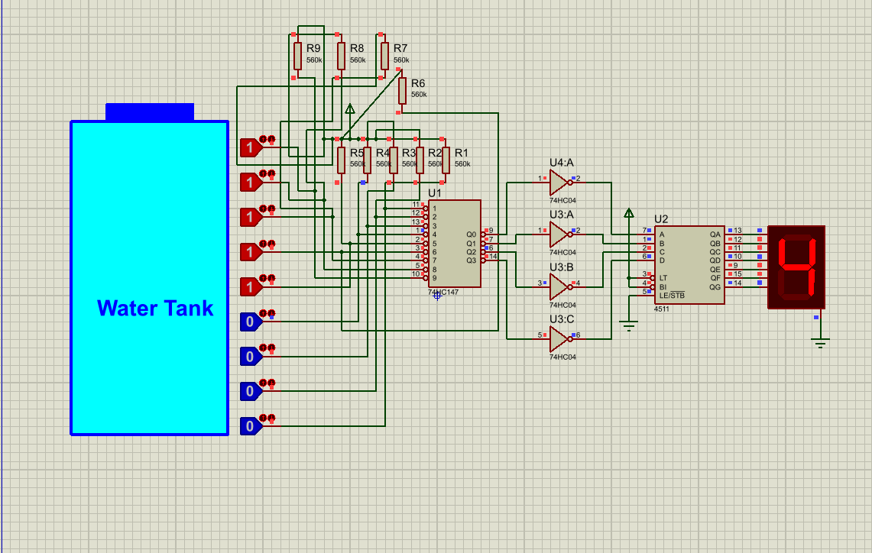
Figure 2 - Water Level - Display shows '4'

Simulation Results Table
Water Level | Inputs LOW | Encoder Out | BCD (After Inversion) | Display | Result
0 | None | 1111 | 0000 | 0 | ✔ Correct
1 | I1 | 1110 | 0001 | 1 | ✔ Correct
2 | I2 | 1101 | 0010 | 2 | ✔ Correct
3 | I3 | 1100 | 0011 | 3 | ✔ Correct
4 | I4 | 1011 | 0100 | 4 | ✔ Correct
5 | I5 | 1010 | 0101 | 5 | ✔ Correct
6 | I6 | 1001 | 0110 | 6 | ✔ Correct
7 | I7 | 1000 | 0111 | 7 | ✔ Correct
8 | I8 | 0111 | 1000 | 8 | ✔ Correct
9 | I9 | 0110 | 1001 | 9 | ✔ Correct

Hardware Implementation
After successful simulation, the circuit was assembled on a solderless breadboard using the components listed in Section 3. Male header pins were used as water-level sensor probes, and hard jumper wires were used for the power and ground rails. The 9 V battery was connected via a battery clip to the LM7805 regulator input.

Breadboard Circuit (Full View)
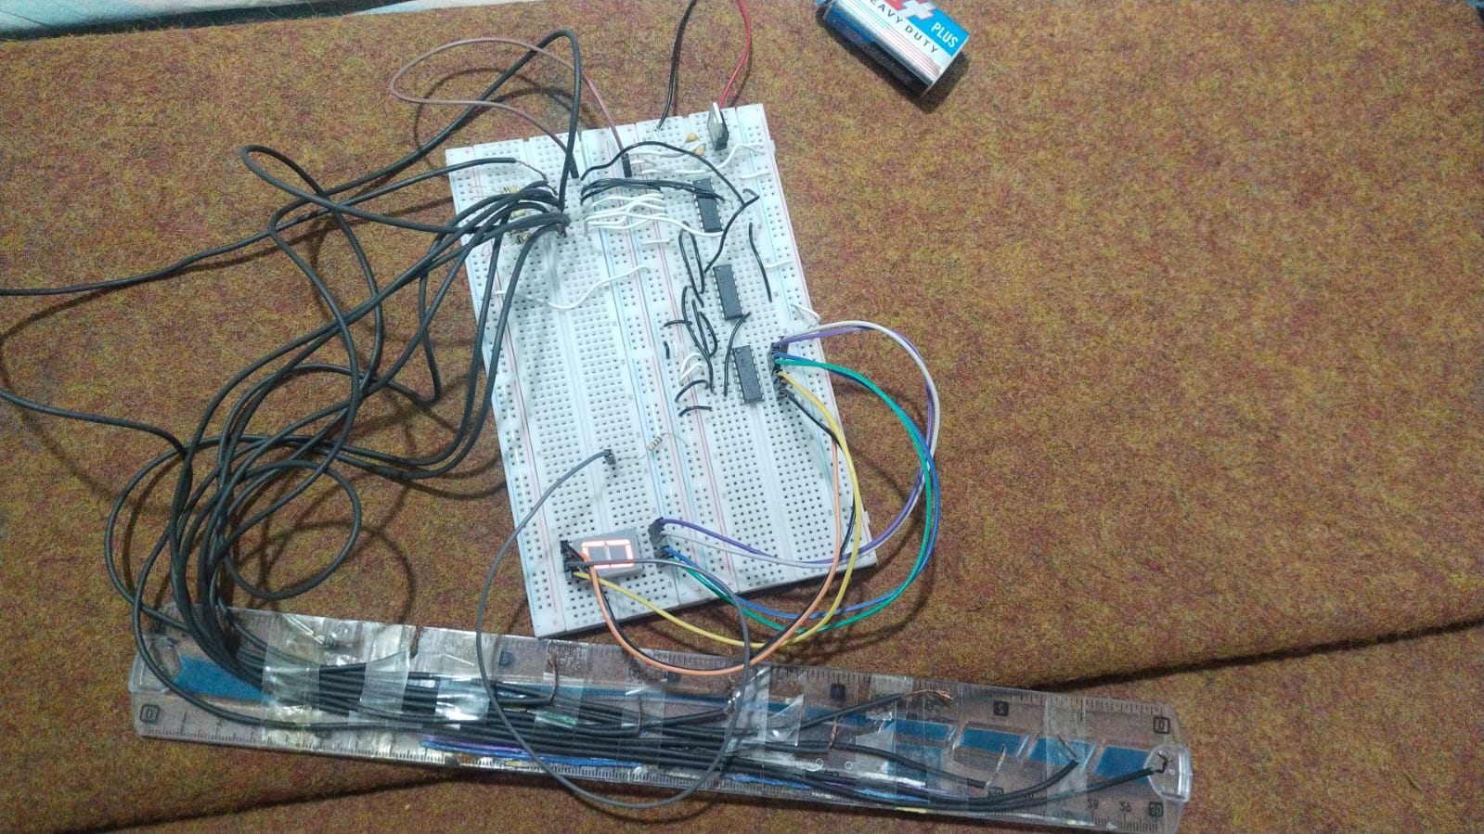
Figure 3 — Assembled breadboard circuit (full view)

IC Close-up (74HC147, 74HC04, CD4511)
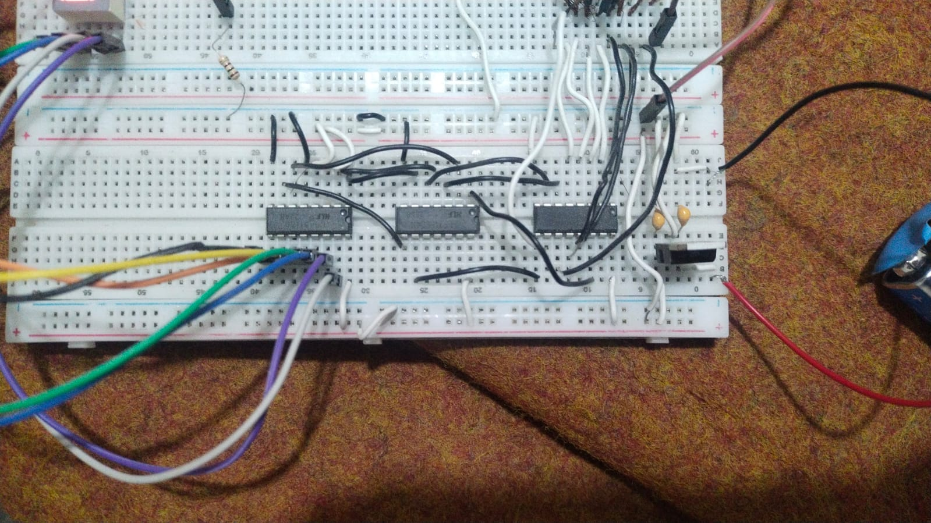

Figure 4 - Close-up of 74HC147, 74HC04, and CD4511 ICs

Display Output (Hardware Test)
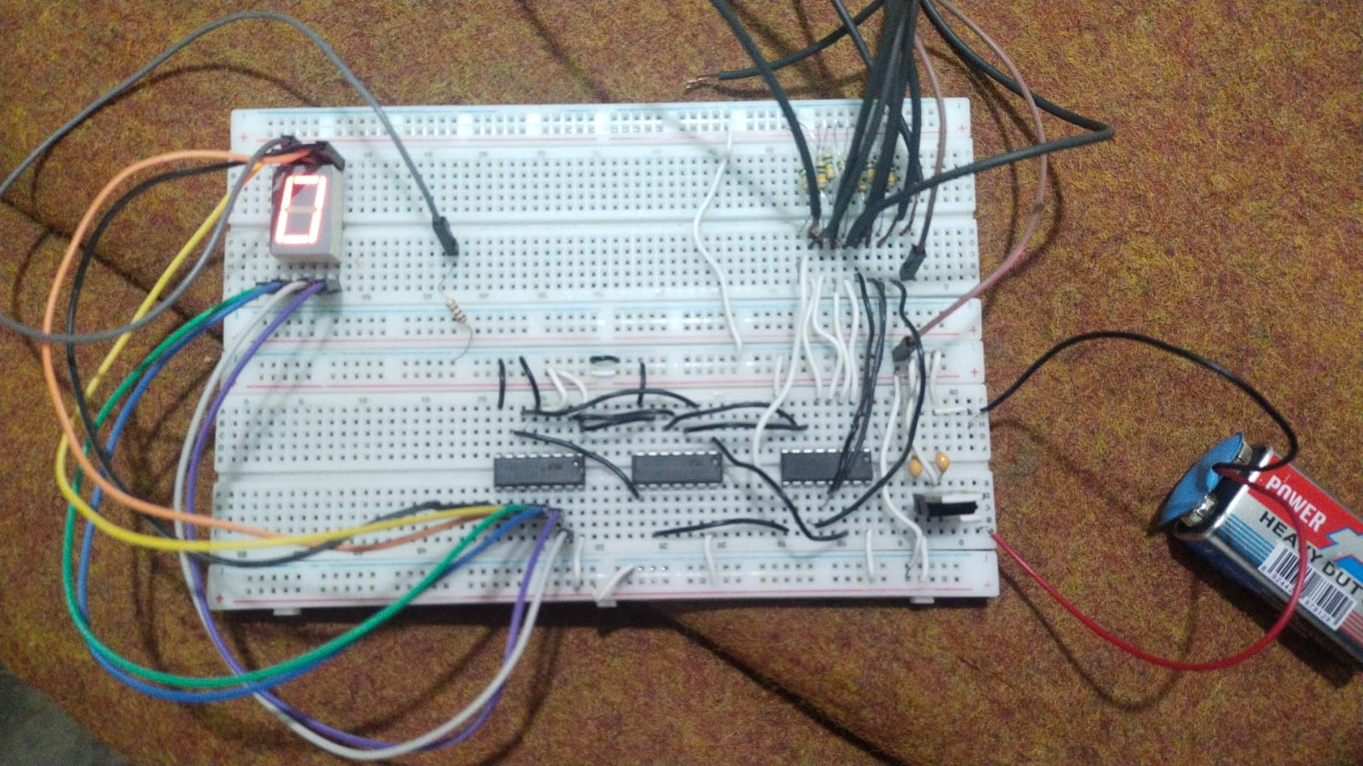
Figure 5 — 7-segment display output during hardware testing

Working Principle
- Water reaches probe I6 - probes I1 to I6 are all submerged and pulled LOW.
- 74HC147 detects I6 as the highest active input outputs 1001 (active-LOW BCD for 6).
- 74HC04 inverts 1001 0110 (correct active-HIGH BCD for decimal 6).
- CD4511 decodes 0110 drives segments a, b, d, e, g HIGH display shows '6'.

Advantages & Limitations
Advantages | Limitations
No microcontroller needed (pure hardware) | Only 9 discrete levels
Instantaneous real-time response | Single-digit display only
Low cost and easy to assemble | Probes may corrode in water over time
Runs on a 9 V battery (portable) | No alarm or pump control output

Conclusion
The Digital Water Level Display project successfully demonstrates the combined use of a priority encoder, hex inverter, and BCD-to-7-segment decoder to build a practical, fully digital level-sensing system. All ten levels (0–9) were verified correct in Proteus 8 simulation, and the circuit was successfully implemented on a solderless breadboard. This project reinforces core Digital Logic Design concepts encoder and decoder operation, active-LOW logic, and IC interfacing in a real-world engineering context.

